**Assignment 3: Medium Access Control Layer**

1. Frames arrive randomly at a 100-Mbps channel for transmission. If the channel is busy when a frame arrives, it waits its turn in a queue. Frame length is exponentially distributed with a mean of 10,000 bits/frame. For each of the following frame arrival rates, give the delay experienced by the average frame, including both queuing time and transmission time.

(a) 90 frames/sec.

(b) 900 frames/sec.

(c) 9000 frames/sec.

1. Consider two nodes, A and B, that use the slotted ALOHA protocol to contend for a channel. Suppose node A has more data to transmit than node B, and node A’s retransmission probability pA is greater than node B’s retransmission probability, pB.
2. Provide a formula for node A’s average throughput. What is the total efficiency of the protocol with these two nodes?
3. If pA= 2pB, is node A’s average throughput twice as large as that of node B? Why or why not? If not, how can you choose pA and pB to make that happen?
4. In general, suppose there are N nodes, among which node A has retransmission probability 2p and all other nodes have retransmission probability p. Provide expressions to compute the average throughputs of node A and of any other node.
5. Suppose four active nodes—nodes A, B, C and D—are competing for access to a channel using slotted ALOHA. Assume each node has an infinite number of packets to send. Each node attempts to transmit in each slot with probability p. The first slot is numbered slot 1, the second slot is numbered slot 2, and so on.
6. What is the probability that node A succeeds for the first time in slot 5?
7. What is the probability that some node (either A, B, C or D) succeeds in slot 4?
8. What is the probability that the first success occurs in slot 3?
9. What is the efficiency of this four-node system?
10. In this problem, we explore the use of small packets for Voice-over-IP applications. One of the drawbacks of a small packet size is that a large fraction of link bandwidth is consumed by overhead bytes. To this end, suppose that the packet consists of P bytes and 5 bytes of header.
11. Consider sending a digitally encoded voice source directly. Suppose the source is encoded at a constant rate of 128 kbps. Assume each packet is entirely filled before the source sends the packet into the network. The time required to fill a packet is the ***packetization delay***. In terms of L, determine the packetization delay in milliseconds.
12. Packetization delays greater than 20 msec can cause a noticeable and unpleasant echo. Determine the packetization delay for L = 1,500 bytes (roughly corresponding to a maximum-sized Ethernet packet) and for L = 50 (corresponding to an ATM packet).
13. Calculate the store-and-forward delay at a single switch for a link rate of R = 622 Mbps for L = 1,500 bytes, and for L = 50 bytes.
14. Comment on the advantages of using a small packet size.
15. Consider five wireless stations, A, B, C, D, and E. Station A can communicate with all other stations. B can communicate with A, C and E. C can communicate with A, B and D. D can communicate with A, C and E. E can communicate A, D and B.

(a) When A is sending to B, what other communications are possible?

(b) When B is sending to A, what other communications are possible?

(c) When B is sending to C, what other communications are possible?

1. A 1-km-long, 10-Mbps CSMA/CD LAN (not 802.3) has a propagation speed of 200 m/μsec. Repeaters are not allowed in this system. Data frames are 256 bits long, including 32 bits of header, checksum, and other overhead. The first bit slot after a successful transmission is reserved for the receiver to capture the channel in order to send a 32-bit acknowledgement frame. What is the effective data rate, excluding overhead, assuming that there are no collisions?
2. A seven-story office building has 15 adjacent offices per floor. Each office contains a wall socket for a terminal in the front wall, so the sockets form a rectangular grid in the vertical plane, with a separation of 4 m between sockets, both horizontally and vertically. Assuming that it is feasible to run a straight cable between any pair of sockets, horizontally, vertically, or diagonally, how many meters of cable are needed to connect all sockets using

(a) A star configuration with a single router in the middle?

(b) A classic 802.3 LAN?

1. In this problem, you will derive the efficiency of a CSMA/CD-like multiple access protocol. In this protocol, time is slotted and all adapters are synchronized to the slots. Unlike slotted ALOHA, however, the length of a slot (in seconds) is much less than a frame time (the time to transmit a frame). Let *S* be the length of a slot. Suppose all frames are of constant length *L = kRS*, where *R* is the transmission rate of the channel and *k* is a large integer. Suppose there are *N* nodes, each with an infinite number of frames to send. We also assume that *dprop< S*, so that all nodes

can detect a collision before the end of a slot time. The protocol is as follows:

* If, for a given slot, no node has possession of the channel, all nodes contend for the channel; in particular, each node transmits in the slot with probability *p*. If exactly one node transmits in the slot, that node takes possession of the channel for the subsequent *(k – 1)* slots and transmits its entire frame.
* If some node has possession of the channel, all other nodes refrain from transmitting until the node that possesses the channel has finished transmitting its frame. Once this node has transmitted its frame, all nodes contend for the channel.

Note that the channel alternates between two states: the productive state, which lasts exactly *k* slots, and the nonproductive state, which lasts for a random number of slots. Clearly, the channel efficiency is the ratio of *k/(k + x)*, where *x* is the expected number of consecutive unproductive slots.

1. For fixed N and p, determine the efficiency of this protocol.
2. For fixed N, determine the p that maximizes the efficiency.
3. Using the p (which is a function of N) found in (b), determine the efficiency as N approaches infinity.
4. Show that this efficiency approaches 1 as the frame length becomes large.
5. To make VLANs work, configuration tables are needed in the bridges. What if the VLANs in the figure below used hubs rather than switches? Do the hubs need configuration tables, too? Why or why not?

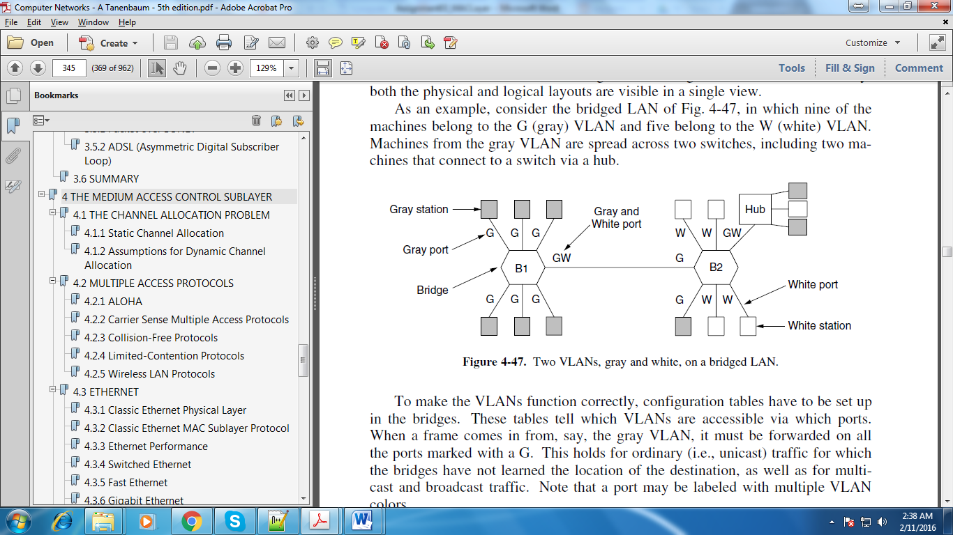

1. The figure below shows several physical layer protocols. Which of these is closest to the Bluetooth physical layer protocol? What is the biggest difference between the two?

